Lake Carmi Association News
July 2020…..One Happy Lake.....Volume 14, Number 3
Brought to you by the Lake Carmi Camper's Association, Inc., and other fine sponsors.
Larry.Myott@uvm.edu.......…https://lakecarmivt.com/

Research Continuing at Lake Carmi
UVM-Vermont DEC Lake Carmi Monitoring Program Synopsis June 2020

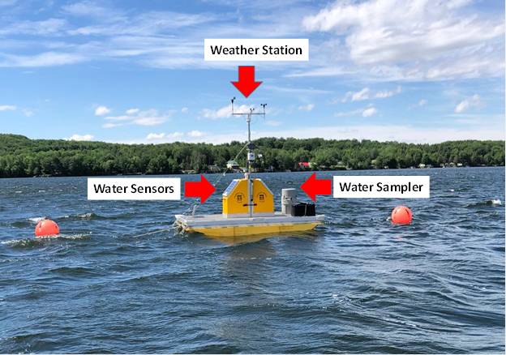
A new research project and monitoring program conducted by faculty and students at UVM in collaboration with and under financial support from VT DEC is underway this summer. The monitoring component of the project is designed to use advanced sensor technology to monitor changes in Lake Carmi's physical, chemical, and ecological properties over the course of the year. The core objective of the work is to understand how Lake Carmi has changed due to the aeration, with particular focus on how the behavior of phosphorus (an essential nutrient that feeds algae populations in the lake) and algae populations themselves responded the aeration program. To do this, the team will compare data collected by their new monitoring program in 2020 to previous data collected by these researchers and the VT DEC date from the years prior to aeration. The overarching product developed from this work should be a comprehensive understanding of how and why the lake's chemistry and ecology changed in response to aeration, which can be used to help guide the management of this precious resource in the future.
On June 12th, the UVM and VT DEC team deployed a new monitoring platform also in the proximity of VT DEC's long-term monitoring site. This platform is capable of monitoring the physical, chemical, and biologyical properties of the water continuously at high frequency (every hour). There is a sensor attached to a winch that is programmed to profile (move vertically from the lake surface to its bottom taking measurements) once every hour. There is also a weather station on the platform so that researchers can monitor changing weather conditions on the lake, and relate those to changes observed in the water with their sensors. All of the data collected by the sensors on the platform (both water and weather sensors) are sent back to computers at UVM through the cellular network every 8 hours so that researchers and managers can monitor

how the lake is changing without driving to the site to collect samples or take measurements manually.
Two pressure transducers, one on land and one fixed below the water to a dock, were deployed in May to monitor changes in the Lake Carmi water level. These sensors also take a measurement every 15 minutes. During this time frame, the team also initiated the collection of sediment and biological grab sampling (collected by a researcher on a boat rather than measured by a sensor) to characterize changes in the phosphorus in the sediment and algae in the water respectively over time. The sediment samples will be collected once a month, and the biological samples are collected every two weeks in collaboration with VT DEC. By analyzing these samples, the research team can compare phosphorus in sediment and algae collected in the lake during 2020 to similar samples compiled during 2018 (before the aerators were turned on) and 2019 when they were turned on later in the summer.
In addition to providing researchers with vast amounts of data, to study the Lake Carmi environment, the platform will be useful for managers to efficiently and continuously monitor conditions, detecting changes in lake chemistry (e.g. oxygen levels) or biology (e.g. occurrence of an algal bloom). In addition to the sensors, the platform is equipped with an automated water sampling system that collects one water sample per day in the water just above the lake's sediment (8.5 meters). Those water samples will be received by the research team and sent to the Vermont Environmental Testing Laboratory for nutrient analysis. These samples will allow the team to know if, when and under what conditions the lake's sediment is releasing phosphorus into the water that could feed algal blooms.
Please reach out to either Oliver Pierson of VT DEC (Oliver.Pierson@vermont.gov) or Andrew Schroth (Andrew.Schroth@uvm.edu) if you have questions about the research or monitoring program or notice any problems with the monitoring systems.

Paid members are permitted a free classified ad in the five issues of the season. Merchandise ads are only for two issues unless renewed. Camp rental ads can run for the whole season, but if you have no more availability, please notify the editor to stop the ad.

Cottage Rentals for the 2020 Season
Under the rules of the Covid19 Pandemic, owners of rental cottages are not allowed to rent before June 15th. However, you should call the rental owners for further information as the rules are changing rapidly.
Cottage for Rent, three bdrm, dock, rowboat, kayaks. Cushman, 925.253.1958, jancushman@comcast.net.
Cottage for Rent, Patton Shore, three bdrm, sleeps up to 15, full kitchen. New England Style rustic, by the week. Rental includes a rowboat and canoe. Pets & children welcome. Contact James Hearne at 215.205.7855 or email: lakecarmicamp@gmail.com.

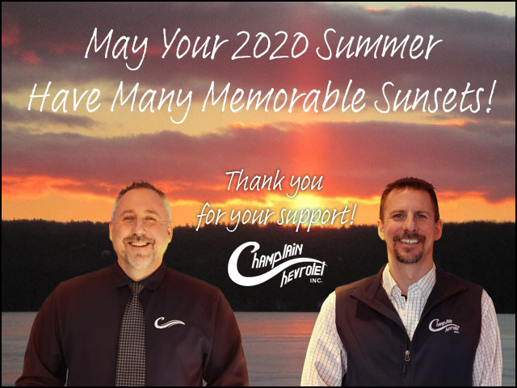
Cottage for Rent, Hammond Shore Road, two bdrm, right on the water, $800/wk, call 802.848.3393.
Cottage for Rent, Hammond Shore Road, fully furnished, bring your own linens, 802.285.6737.
Cottage for Rent, Westcott Shore, three bdrm, fully equipped. May thru October $850/week. 514.220.7079 days, 450.359.9138 evenings. Email: sjones@erbgroup.com.
Cottage for Sale, Westcott Shore with 180' frontage. Updated five bdrm, two baths, nice kitchen. Fully furnished sleeps 12. Asking $196,500. Call Nancy @ 603.231.0617 or Bob @ 802.285.6620. Email: nlumnah@yahoo.com.
Cottage for Sale, 234 Hammond Shore Road, 99 yr. Lease, two bdrm, one bath, north/westerly views. Bruce & Debbie Bushey, 802.285.6138 or 802.355.1969. Email, dbbushey@gmavt.net

For Sale
Pure Franklin Maple Syrup. Deuso Family Maples, Call Howard or Pam. $35/gallon, $20/half-gallon, other sizes available. Call 802.285.2031.
Vermont Maple Syrup, $40/gal, $22/Half gal, smaller sizes available. Do your Christmas shopping now. Call or text 802.393.1241. Bruce & Sharon Patterson, 78 Patterson Point at Lake Carmi.

Services
North Country Maintenance, handyman Henry
Neuberger, (cell) 802.393.1107 or (home) 802.933.8958. No job to small, but no yard work. Free estimates.
Need a Painter? Call Dave Brown, professional and local painter - interior, exterior, house painting. 802.326.4174.

Become an LCCA member for the 2020 season. The dues are just $50.00 per year. LCCA members are committed to our lake in so many ways. Some are volunteers who help out wherever and whenever they are able; some are here to enjoy a week or more in this pristine setting. We only ask that you become a member of your association and do what you can. Your comments are always welcome, contact any of the directors, or send the editor your thoughts for sharing at your Directors board meetings. Become an official member of the Lake Carmi community, send in your membership form, and dues check, payable to LCCA, Inc. to LCCA, Inc. P. O. Box 1, Franklin, VT 05457. Please send us your correct membership information and your dues check. Thank you.
Please mail your check and this form to: LCCA, Inc. P.O. Box 1, Franklin, VT 05457

Name _________________________________ ○ Renewal ○ New ○ Gift Membership

Attached is my check for 2020 Dues, in the amount of $50.00, made payable to LCCA., Inc.
Cottage 911 mailing address, if applicable _________________________________________
Summer Mailing Address ______________________________________________________
Winter (off-season address) _____________________________________________________
Cottage Telephone ______________________ Off-season telephone ____________________
Please register your Email Address, You’ll get the Newsletters and other useful information, but no spam or advertising: Please print ____________________________________
Contribution to the annual LCCA Fireworks are gratefully accepted, $________
Contribution to the LCCA Water Quality Fund are very welcome, $_________

LCCA use only, Date received __________

Late June Update on Aeration
The Lake Carmi Aeration System, designed to keep the lake mixed and to prevent low oxygen levels at the lake bottom (which can create conditions where sediment phosphorus is released into the water column), was turned on in early June 2020. Since then, the northern compressor powering half the system has been working perfectly. The southern system at the state park has had some electrical surge issues that have knocked it offline a few times. As of June 19th, it is offline. DEC is working with the aeration system contractor (Everblue Lakes), the electrician on the project, and the local electric supplier, to find a solution to this surge problem. We are aiming to have the system back online by June 23rd. The DEC has also funded tree-planting at the State Park site to provide shade to help keep the compressor cooler; four trees were planted around the unit recently. If you have any questions about the system, please contact Oliver Pierson at oliver.pierson@vermont.gov.

LCCA Dues Time, 2020
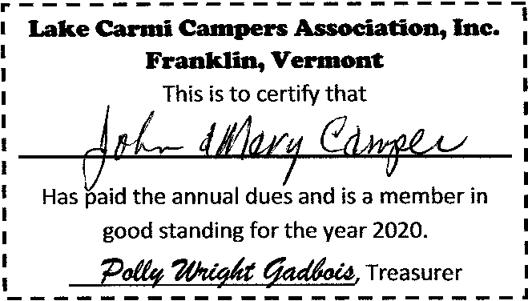
Due to the Covid 19 Virus, we would find it very difficult to go door to door to get dues this summer. The dues have been coming in nicely, but we are only about 1/3 of the way there. The annual dues is only $50.00 again this year. Please mail your dues and a copy of the membership form, that's in this newsletter, to LCCA, Inc. P.O. Box 1, Franklin, VT 05457. We will make sure that each member gets their annual Window Card and Membership Card. Perhaps under the door or hanging on your doorknob.
Franklin Telephone Co., Inc.
5217 Main Street P.O. Box 96, Franklin, VT 05457
802.285.9911
High Speed Internet, Local & Long Distance Service, Voicemail, Caller ID

Serving Franklin since 1894
Another LCCA Member Owned Business
Membership chair Marion Benevento reminds us of the many demands that our dues dollars help to provide. Those include the Franklin County Sheriffs patrols in the winter season; LCCA Newsletter, volunteer water sampling program of the lake and its tributaries, Celebrate Lake Carmi (which had to be canceled this summer), assistance with the new lake aeration system and other research projects, just to name a few. Please take a few minutes and send in your dues, it's very important to the success of your association.

Patton Road Road Maintenance
A reminder to the Patton Road residents, you got a letter about the road fund and the response was very nice. Pete Benevento says they are getting ready to order the materials for summer maintenance. There is another way to help put some money in the road fund, a group of volunteers will collect bottles and aluminum cans that have a VT deposit. Containers are at the driveway of 613 Patton Shore Road for deposit. VT liquor bottles also have a deposit, so those can be contributed as well. All proceeds will go toward road maintenance. Please, no plastic water bottles or wine bottles.

President Pete Benevento says:
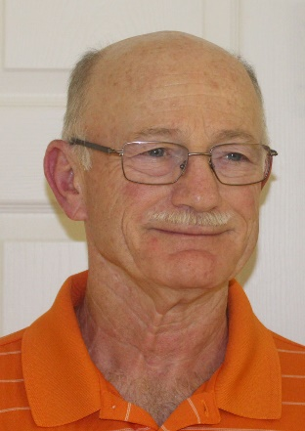
They say, "the more things change, the more they remain the same," and this was one of the thoughts that came to mind on our arrival at Lake Carmi. It was the latest we had ever opened camp and now, due to the pandemic, were quarantined. The lake and its surroundings were as beautiful as ever, and its residents remain second to none. Numerous people offered to shop for us and run errands during the quarantine. It was quite a welcoming committee. We greatly appreciated it. It was good to be home.
I know the "new normal" is a "fluid situation" regularly changing with revisions from Governor Scott. We escaped the full two-week quarantine early by getting tested for COVID 19 after seven days of no symptoms. If you don't receive a telephone call on the third day, you may end your quarantine. Ten days are better than fourteen. The Health Department followed up a few days later with a letter confirming our tests were negative.
We noticed while shopping that most people wear masks and adhere to social distancing. It speaks volumes to the fact Vermont is one of the states most effectively dealing with the virus. No small feat considering the rising virus rates in the lands around us. Vermont and our lake Carmi certainly makes one feel more comfortable in a very uncomfortable time.
The virus may have forced us to cancel our July 4th festivities, but it has not stopped the work to help our lake. There has never been a more concerted effort to help improve our water quality. From the Aeration Project to Groundwater and geological studies for major culvert replacements to Private and Park Roads Assessments, to the UVM Research Platform for extracting samples in the Lake and its Tributaries, UVM Extensions’ Work with Farmers in the Watershed, everything points to very positive changes at Lake Carmi. It may not happen tomorrow, but it will happen. The LCCA remains committed to working with the State and local organizations to improve Lake Carmi. To get a detailed account of all the good things happening at the lake, please visit VT DEC's website, https://dec.vermont.gov/watershed/restoring/carmi.
The Franklin Watershed Committee (FWC) is in the process of hiring a new Coordinator. The new coordinator will become involved in all ongoing initiatives at the lake. One ongoing effort is the FWC's sponsorship of the Boat Greeter Program at the north ends Fish & Wildlife Boat Launch. Lake Carmi resident John McHugh is our local Boat Steward inspecting boats entering and leaving the lake for aquatic invasive species. John is an essential part of improving the water quality of the lake. The FWC also continues assisting campers with their Septic Pump Out Program. In conjuncttion with the LCCA, the FWC offers a $75.00 rebate for septic pump-outs and a $25.00 rebate when a Port-O-Let is rented for use at camp. Just mail a copy of the receipt to FWC, P O Box 79, Franklin, VT 05457. Please make sure you include a copy of the receipt and an address where the rebate check should be mailed to.
Last year the LCCA unveiled a new website. The website is a perfect platform to showcase the lake to those making queries about Lake Carmi. The website is currently a work in process, but we invite you to visit at www.lakecarmivt.com.
Lastly, the one event we did not cancel was "Light Up Lake Carmi." Please light up your camp over the July 4th holiday week in tribute to the healthcare workers and first responders. They have done much over the last few months to keep us safe & healthy. They deserve our thanks and praise. So get out those lights to show them our gratitude.
That's it until next month. I have exceeded my allotted page, and once again, I am tempting the fates with my editor. I missed my deadline last month and wound up out of the newsletter. He can be feisty. Hopefully, he has restored me to good graces to at least end up on the last page.
Finally, another old saying is, "You can never go home," but they sure weren't traveling to Lake Carmi! Stay safe, stay healthy, and eventually, I will see you around the lake!
The Lake Carmi State Park includes over two miles of frontage on the south and east shore of Lake Carmi. Most of the 482-acres were purchased in 1959. The park was developed in stages through the 1960’s.

Franklin History Corner, Morses Line
Many Lake Carmi campers and visitors to Franklin are familiar with the Morses Line Border Crossing. But did you know that this Canadian-USA port of entry was once a thriving little village? The following article is from the Border Patrol History Project.
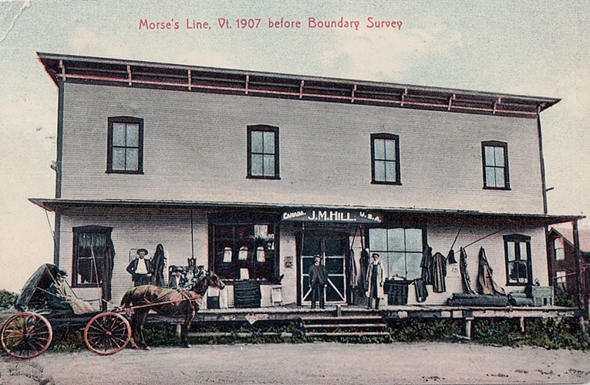
Sometime in the late 19th century, J. Morse built a general store straddling the line at boundary marker No. 621. An 1871 Beers Atlas Map of Franklin County shows the J. Morse Store located at the border, with a byway leading to the store from the village of Franklin and another from the Quebec side of the line (Morses Line Road). A later issue of the Rand McNally & Company (1895) map of Franklin County shows Morses Line located on the line.
The first line store burned down, J. Morse quickly replaced it. James (Jimmy) Monroe Hill Jr., whose mother was a Morse, often visited Morse family relatives such as the two Fuller brothers who owned the farms abutting the border on either side of Morses Line Road. He built a farmhouse on the U. S. side of the border for his bride, and a large stable/barn on the Quebec side, for his driving and racehorses.
Jimmy Hill stocked his store with everything the surrounding farmers and their families might need. But then, catastrophe struck a second time, burning down the Morses Line store. Proprietor Hill immediately rebuilt bigger and better. At one point, the Morses Line Post Office was located in the store, as well as the Franklin Telegraph office. Canadians and Vermonters journeyed to the line store from miles around, entering the store through separate doors on either side of the boundary marker, shopping freely throughout the store, and departing laden down with purchases, without going through customs and immigration.
The tiny hamlet grew on both sides of the line to include several farmhouses, a blacksmith, a wheelwright, an apiary, and during prohibition: the Bucket-of-Blood bar, which also straddled the line.
Ref: http://www.franklinvthistorical.com/JMHill.html.
A History of Franklin, 1789-1989, is available from Haston Library or the Franklin Telephone Company for $20.00.

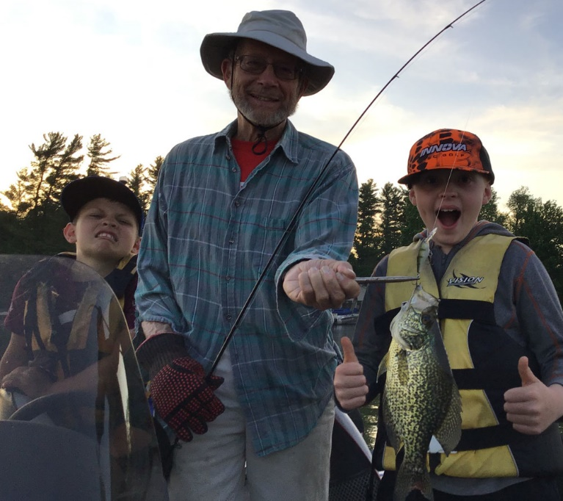
Fishing Contest 2020
Unusual catch in Lake Carmi. William Bailey, 11, caught a black crappie on June 17th while fishing with his brother Wesley, and grandfather, Ernie Englehardt. This is the first crappie caught by anyone in this family who has been fishing at the lake since 1978.
Remember to enter your walleye, pike, perch, smallmouth or largemouth bass in the fishing contest. The entry form is at the Franklin General Store. The rules are in the April and June issue of the newsletter, and posted at the store.
Avery’s
Snow Plowing & Lawn Care, LLC

Spring/Fall cean up, lawn mowing, hedge trimming, garden mulching.
Light trucking & excavating. Topsoil, stone, gravel, mulch, etc.
Call Avery & Megan Stanley, 802.309.5203

Lead and Loons Don’t Go Together
Park Side Grill
Main Street, Enosburg Falls
Good Food, Good Portions & Fair Prices
Pizzas, Burgers, Grinders & more
Eat In or Take Out, 933.5522
Monday – Thursday, 11 a.m. – 8 p.m.
Friday & Saturday, 11 a.m. – 9 p.m.

Another LCCA Member Owned Business, Cathy Godin Derby
Loons and other water birds can die from lead poisoning after they swallow lead sinkers and jigs lost by anglers. Up to half of adult Loon deaths are the result of lead poisoning. We need you to switch to nonlead fishing tackle and help spread the word here at the lake. Lead sinkers are prohibited under Vermont fishing rules and regs. Lead is the leading cause of observed loon deaths. It is illegal to use lead sinkers weighing ½ ounce or less.

What Can You Do to Help?
● Use nonlead fishing tackle.
● Spread the word. Tell your friends and neighbors about the problem and encourage them to switch to nonlead alternatives.
● Remove lead sinker fand jigs from your tackle box.
● Maintain a respectful distance from loons and other wild animals. Use binoculars to get great views.

This invasive wild plant is all around, be very aware do not go pick the pretty flowers.

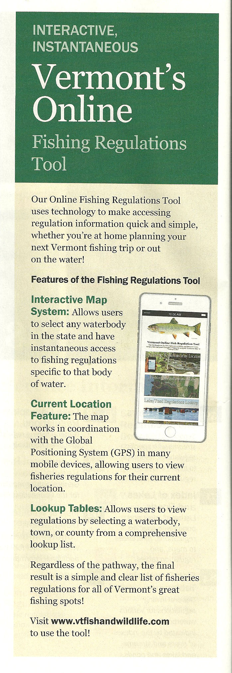
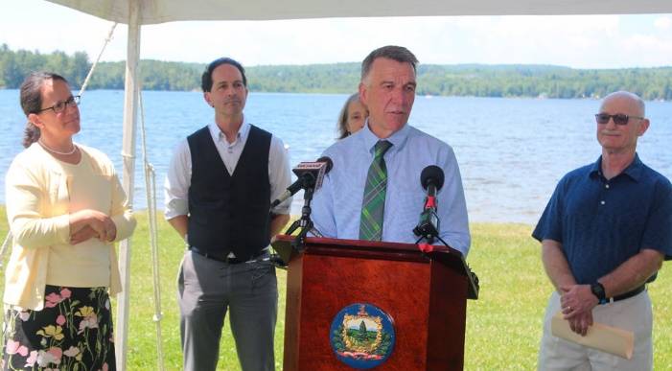
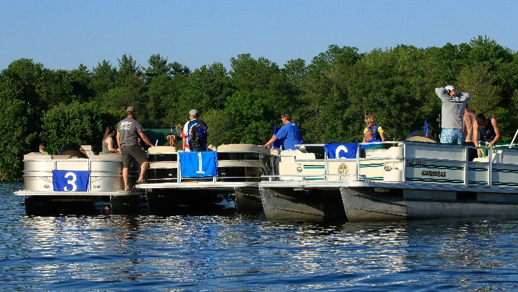
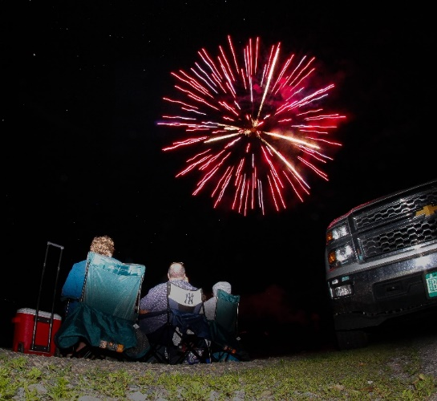
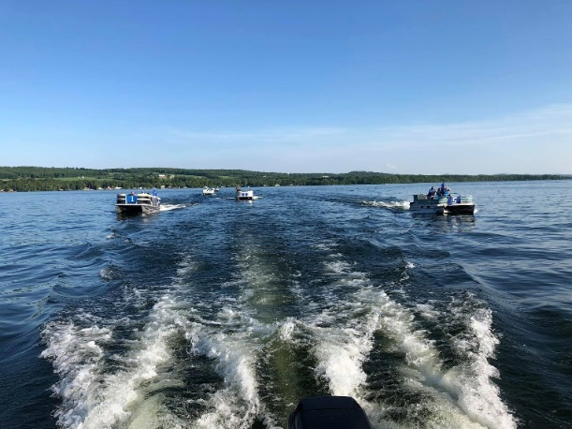
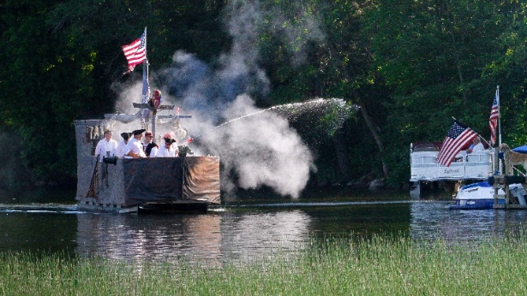
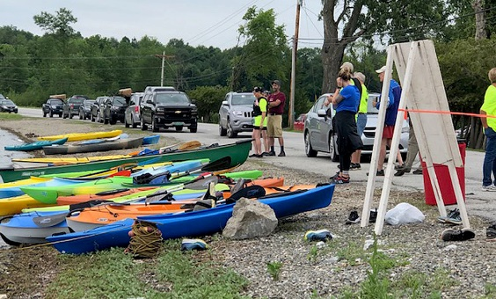
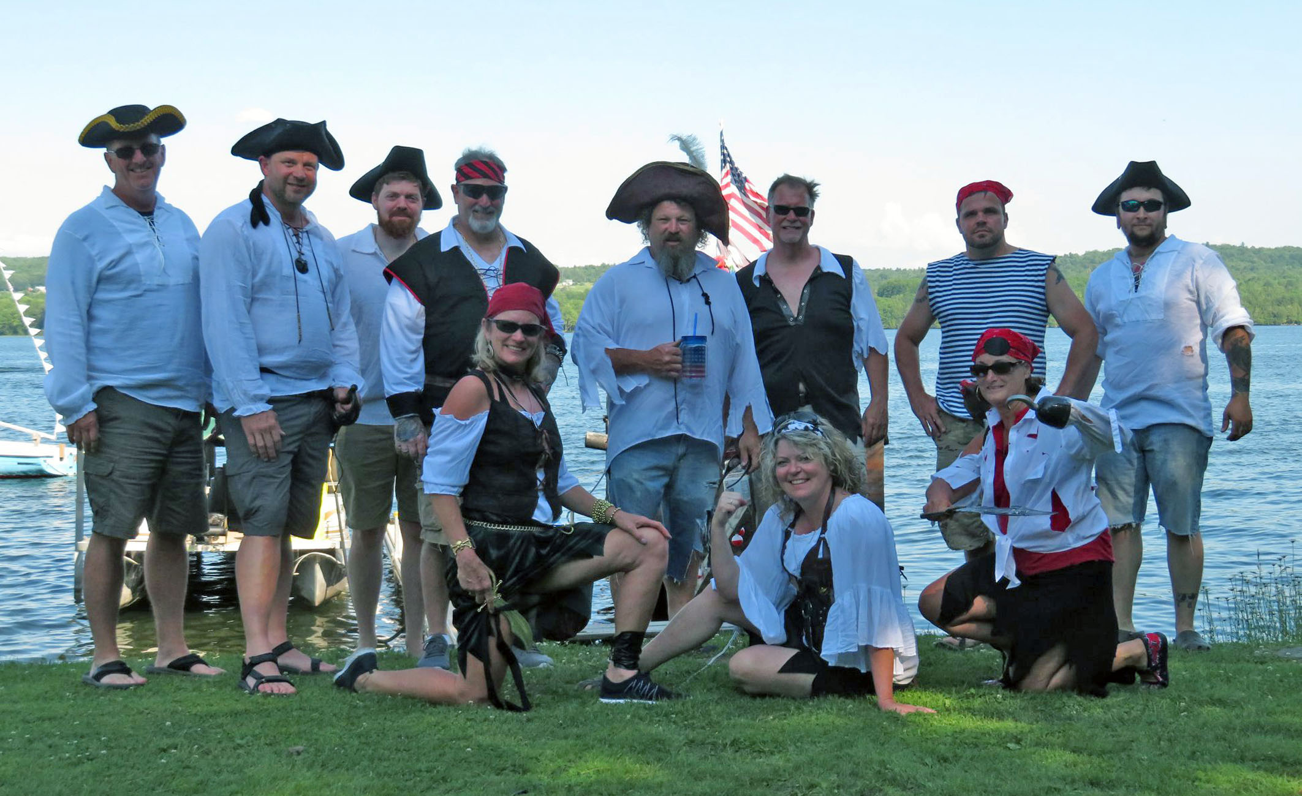
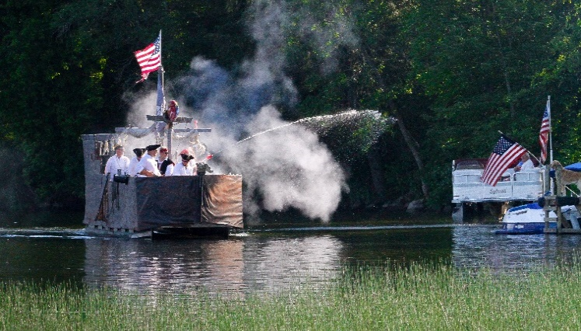
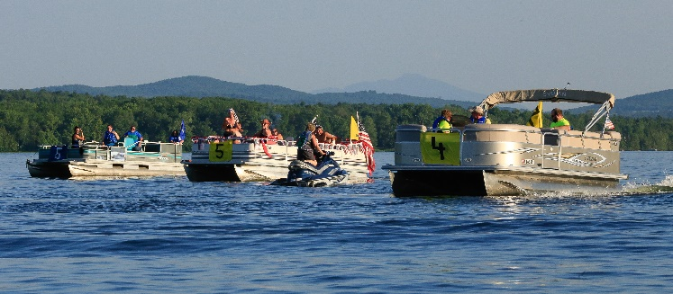
Memories, a Beautiful 2019 Season

